Niche overlap decreases with increasing resource availability in a tropical plant-pollinator network.

*MS submitted to The American Naturalist in the “Major Article” category.*

Ben G. Weinstein, corresponding author, email: [bweinste@life.bio.sunsysb.edu](mailto:bweinste@life.bio.sunsysb.edu)

Department of Ecology and Evolution, Stony Brook University, Stony Brook, New York 11794; USA

Catherine H. Graham, email: [Catherine.Graham@stonybrook.edu](mailto:Catherine.Graham@stonybrook.edu)

Department of Ecology and Evolution, Stony Brook University, Stony Brook, New York 11794; USA

Contributions BW, CG developed the conceptual ideas for the MS; BW conducted the analyses; CG, BW and CG wrote the MS

Keywords:

Contents:

# Introduction

* Ecological specialization is a cornerstone of community ecology. The majority of species feed on a subset of available resources and have distinct morphological and behavioral adaptations shaped by natural selection. By minimizing niche overlap, species reduce interspecific competition and gain access to private resources. Specialization promotes species occurrence and community stability by setting differing limiting factors for each species (Levins). In addition, ecological specialization is proposed explanation for latitude diversity patterns, the evolution of higher taxa () and the diversity of life ().
* The specialization of species interactions, such as plant-pollinator relationships, depends on the reliability of pollinators and effectiveness of pollen transfer (Thompson). The dominant theory for pollinator niche breadth posits that selection should promote adaptations for the most effective pollinator (Stebbins 19XX). However, this hypothesis ignores how a pollinator interacts with the surrounding biotic environment and assumes that fitness costs based on morphological tradeoffs are constant throughout the year (Thomson 2003). The existence of pollinator of tradeoffs are rarely proven, and pollinator behavior can change throughout the year (Petanidou et al. 2008). In this paper, we evaluate two hypothesis for the relationship between niche overlap and network connectance based on available resources.
* Optimal foraging theory suggests that niche overlap should increase as available resources increases. When there are an abundance of available resources, species do not suffer energy loss from exploitative competition(). Local patches are resource rich and difficult to exhaust before the replenishes. Species reduce time spent between patches as they minimize foraging for their specialized resource and choose more general resources.
  + This tradeoff is well known in cichlid fishes, where the cranial morphology suggest highly specialized behavior, but observation often show wide niche breadth (‘Liem’s Paradox’ XX)
  + Wilson (1998) suggested that the cichlid undermine the assumption of tradeoffs in foraging efficiency where the presence of abundant easy to use resources come at no cost for morphological specialization.

In hummingbirds tradeoffs are manifested in morphological traits, where species tend to forage on corollas that match their bill length (Stiles et al. 1978; Vizentin-bugoni et al. 2014). Mismatches in bill morphology reduce foraging efficiency, creating an inverse relationship between specialized morphology and niche breadth (Maglianesi et al. 2014).

* + In the tropical cloud forest, flower availability changes drastically throughout the year (Stiles 1975).
* In addition many specialist show temporal change in feeding behavior.
* In this work we evaluate two hypothesis for hummingbird foraging behavior based on optimal foraging theory and competition theory.
  + In our study nectar is the non-equilibirial resource with niche breadth measured as the diversity of plants visited and specialization the diversity of plants visited versus the number of available plants.
* In light of this variation in resource abundance, we test two opposing theories exist for how pollinators should choose potential nectar resources.

### Niche Overlap should decrease as available resources increases (‘Competition’)

* Stable coexistence of competing species is achieved through niche differentiation that reduces overlap among competitors. Species should be coevolved to abundant resources. Differences in morphology will lead to disruptive selection, allowing coexistence of many potential competitors.
  + MacArthur and Levins 1967, Abrams 1983), and niche partitioning (sensu MacArthur 1958, Pianka 1974, 1976, Schoener 1974)
* At times of low resource availability species cannot be choosy, and must forage on whatever plants are available. When resource availability is high, species could reduce interspecific competition by eliminating potential competitors.

### Trait-Matching and Niche Overlap

The above hypothesis predict a pattern of niche overlap and resources, but provide no direct mechanism by which species choose resources. It has been repeated suggested that hummingbird foodplant specialization is mediated through bill-corolla phenotype matching (Feinsinger and Colwell 1978). We therefore expect that as specialization increase, the strength of phenotypic matching should decrease. When given a choice, species should pick the flowers which reduce competition and closely match their bill morphology.

# Methods

* Data Collection
  + Study site Data were collected at the Maquipucuna Research Station and Santa Lucia Ecolodge, Ecuador (0.118 S,-78.612 W) between June and August 2013 along an elevation gradient from 1300 m to 2500 m. The area contains regenerating secondary and primary cloud-forest, and has a warmer dry season from June to September (Webster and Rhodes 2005).
  + Plant resources To measure available resources, we counted the number of hummingbird pollinated plants within 5 m of pre-established trails along six 1 km transects. Each transect covered approximately 200 m of elevation change. For each plant, we estimated the number of total flowers by taking the average number of flowers on 3-5 stalks and multiplying this value by the total number of stalks on a plant. Surveys were repeated two times a month. All hummingbirds visiting flowers were noted during these transects and tagged with a GPS point.
  + Hummingbird plant interactions In addition, we used time-lapse cameras to monitor hummingbird visitation. Flowers in bloom were noted during each transect, and cameras were placed 1-3 meters from focal flowers. Cameras turned on automatically at dawn and recorded an image every second for at least two days.
  + We used the computer vision program MotionMeerkat to identify images where hummingbirds were observed (Weinstein 2014).
* Network Analysis
  + Measures of niche overlap
    - Niche Overlap
    - Connectance
    - Clustering
  + Why was each measure chosen?
* Null models
  + To address sampling constraints (Blüthgen 2010)
  + Randomization Methods

**Figure 1. Conceptual figure showing patterns of interactions between birds and flowers for high and low niche overlap, connectance and clustering. The bottom panel shows two hypothesized relationship between available resources, specialization, and trait matching.**

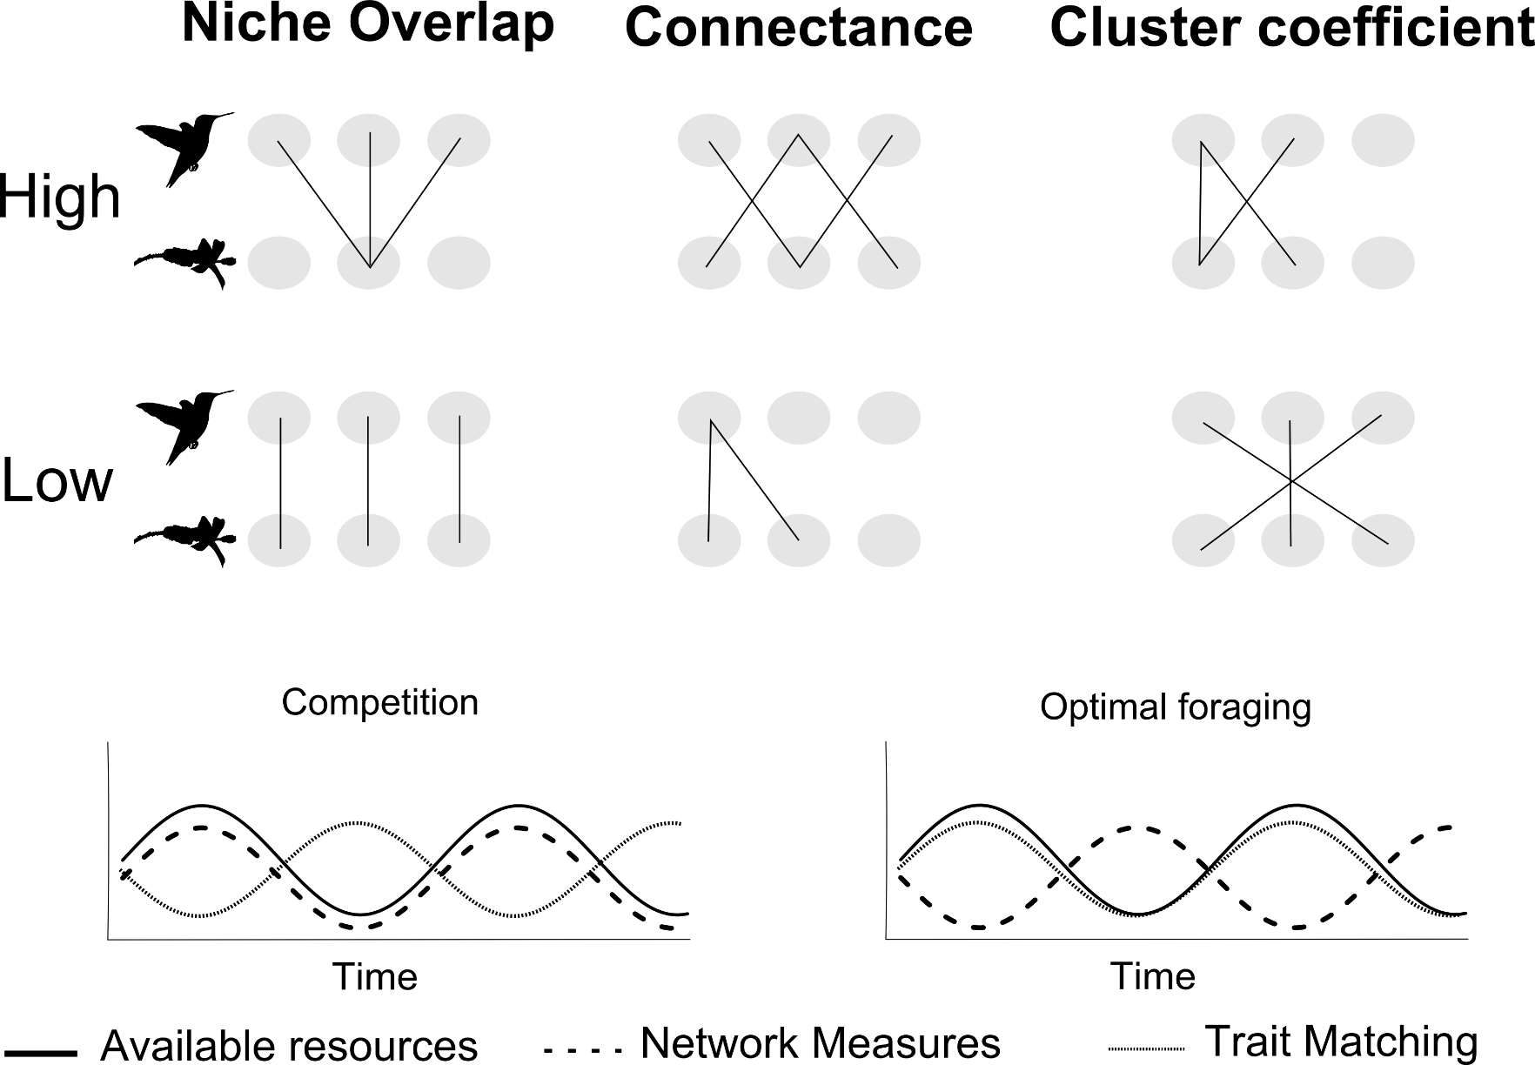

**Figure 2. Flower abundance per month for each transect.**

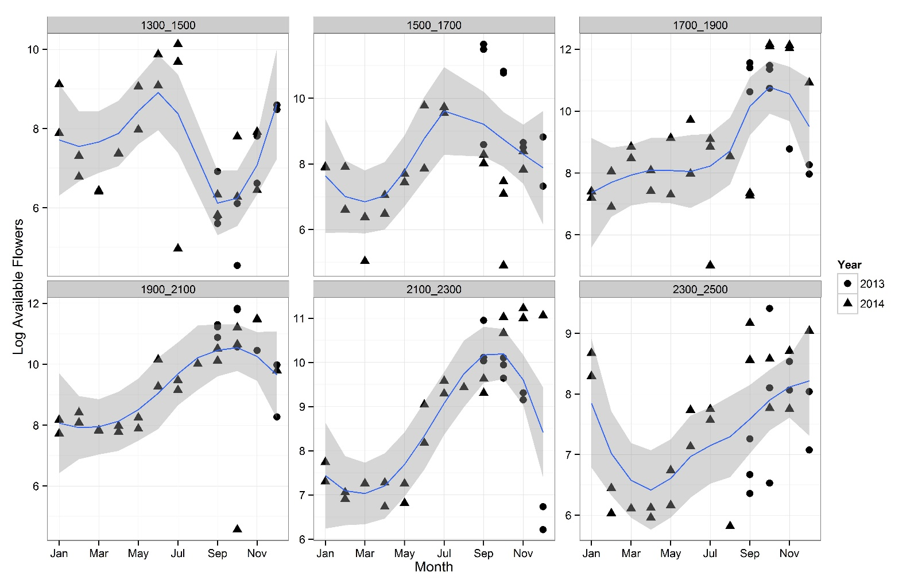

**Figure 3. Measures of hummingbird plant interactions through time (points) as compared to a null model maintaining the number of observations (shaded region).The size of the point is proportional to the number of interactions measured for each month.**

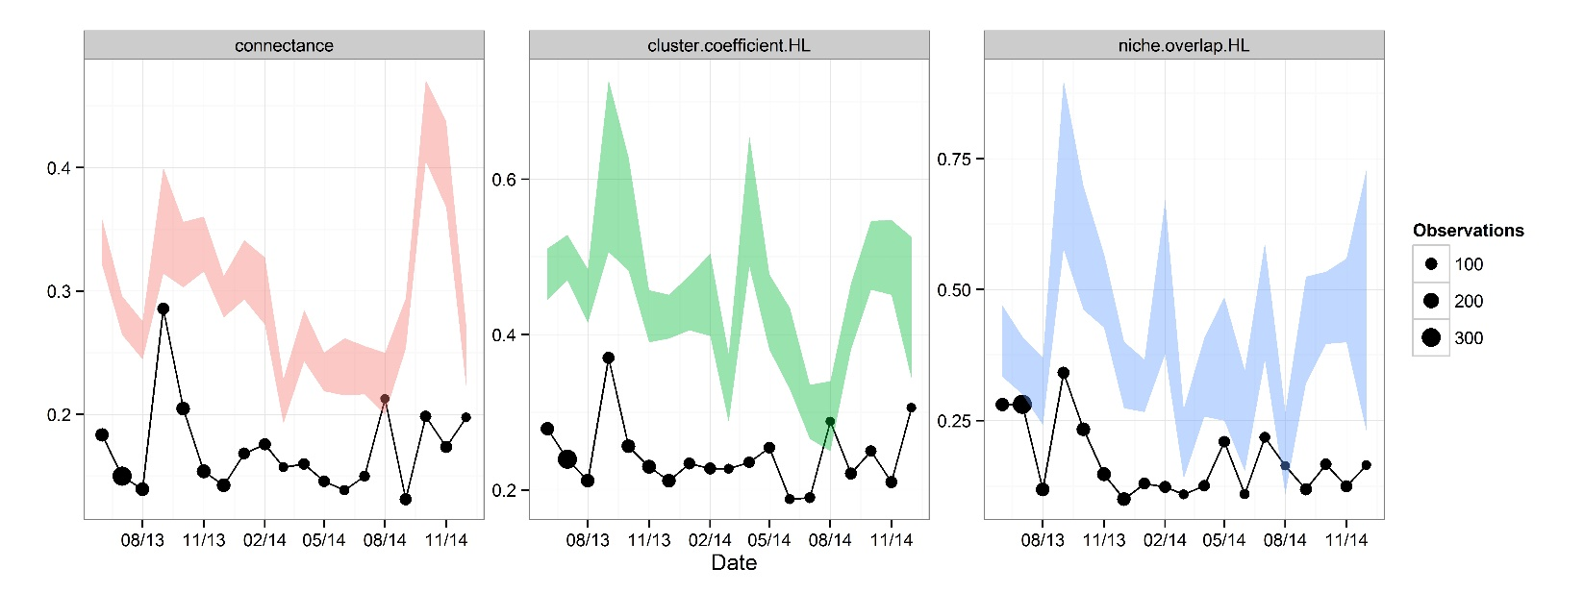

**Figure 4. Connectance, clustering and niche overlap as a function of available resources. Point size is proportional to number of interactions observed that month.**

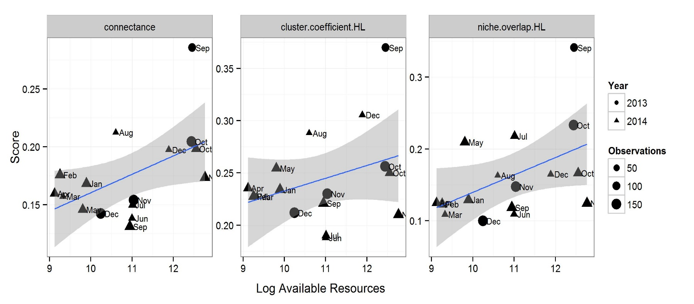

## 

**Figure 4. The correlation coefficient among bill and corolla lengths decreases as a function of time (left) and available resources (right). The gray ribbon is a null randomization of the correlation structure which maintains the number of interactions per month.**

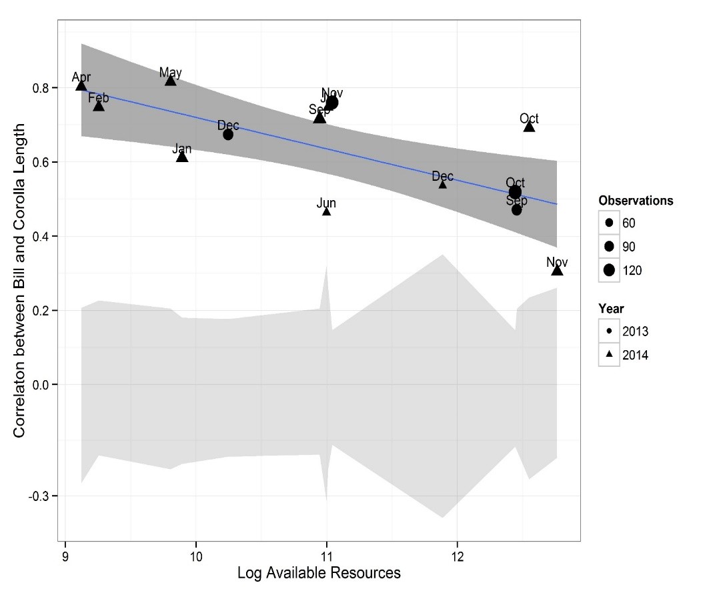

**Figure 6. Difference between bill length and corolla length for high and low abundance times. High abundance times are defined as months with 75th or higher quartile of flower abundance for each hummingbird species.**

# 

# Results

* How many plant records?
* How many bird records?
* How many interactions?
* Network Measures as a function of resources (and by species type?)
  + Niche Overlap
  + Connectance
  + Clustering
* Trait Matching
  + Correlation
* Long and Short Billed Species

# Discussion

* Niche Overlap increases with available resources
* Trait Matching decreases with available resources
* Support for Wilson’s Solution liem’s paradox
* Coevolution and pollination web

## Comparable literature

* Correa, S., & Winemiller, K. (2014). Niche partitioning among frugivorous fishes in response to fluctuating resources in the Amazonian floodplain forest. Ecology, 95(1), 210–224.
* In general, dietary shifts in response to changes in the availability of preferred foods reduced interspecific niche overlap and may be a mechanism that facilitates coexistence in this species-rich fish assem- blage. During the period of greatest fruit production, diets of all six species were dominated, to varying degrees, by fruits and seeds, yielding broadly overlap- ping trophic niches among species.
* Trait packing, coexsitance and tropical specialization
* This niche partitioning mechanism is central to many explanations of the latitudinal gradient in species diversity, i.e that greater resources lead to finer subdivision of niche space, and promotes reproductive isolation.
* In this paper we have avoided abundance weighted measures of specialization (see Schluening and Bluthgen) due to the ongoing confusion in this literature. Specialization seems often defined as the fidelity of interactions with respect the abundance of the partners. Quantatitive approachs to network specialization (see H2') only consider
* Dalsgaard, B., Magård, E., Fjeldså, J., Martín González, A. M., Rahbek, C., Olesen, J. M., … Svenning, J.-C. (2011). Specialization in plant-hummingbird networks is associated with species richness, contemporary precipitation and quaternary climate-change velocity. PloS One, 6(10), e25891. <doi:10.1371/journal.pone.0025891>
  + Historical effect on specialization.

# Literature Cited

Blüthgen, N. 2010. Why network analysis is often disconnected from community ecology: A critique and an ecologist’s guide. Basic and Applied Ecology 11:185–195.

Feinsinger, P., and R. Colwell. 1978. Community organization among neotropical nectar-feeding birds. American Zoologist 18:779–795.

Lever, J. J., E. H. van Nes, M. Scheffer, and J. Bascompte. 2014. The sudden collapse of pollinator communities. Ecology letters 17:350–9.

Maglianesi, M., N. Blüthgen, K. Böhning-Gaese, and M. Schleuning. 2014. Morphological traits determine specialization and resource use in plant-hummingbird networks in the Neotropics. Ecology In press.

Petanidou, T., A. S. Kallimanis, J. Tzanopoulos, S. P. Sgardelis, and J. D. Pantis. 2008. Long-term observation of a pollination network: fluctuation in species and interactions, relative invariance of network structure and implications for estimates of specialization. Ecology letters 11:564–75.

Schleuning, M., J. Fründ, and D. García. 2014. Predicting ecosystem functions from biodiversity and mutualistic networks: an extension of trait-based concepts to plant-animal interactions. Ecography n/a–n/a.

Stiles, F. 1975. Ecology, flowering phenology, and hummingbird pollination of some Costa Rican Heliconia species. Ecology 56:285–301.

Stiles, F. G., S. Biotropica, N. Sep, D. C. Rica, C. Universitaria, C. Rica, F. La, et al. 1978. Temporal Organization of Flowering Among the Hummingbird Foodplants of a Tropical Wet Temporal Organization of Flowering among the Hummingbird Foodplants of a Tropical Wet Forest 10:194–210.

Thomson, J. 2003. When is it mutualism? The American Naturalist 162:S1–S9.

Vázquez, D. P., N. Blüthgen, L. Cagnolo, and N. P. Chacoff. 2009. Uniting pattern and process in plant-animal mutualistic networks: a review. Annals of botany 103:1445–57.

Vizentin-bugoni, J., P. K. Maruyama, and M. Sazima. 2014. Processes entangling interactions in communities: forbidden links are more important than abundance in a hummingbird–plant network. Proceedings of the Royal Society B: Biological Sciences 281.

Weinstein, B. G. 2014. MotionMeerkat: integrating motion video detection and ecological monitoring. (S. Dray, ed.)Methods in Ecology and Evolution n/a–n/a.